Mood analysis

# Introduction

## Game selection

**Mount & Blade: Warband** (TaleWorlds Entertainment, 2010) - A medieval combat simulator focusing on realistic warfare.

**Kingdom Rush** (Ironhide Game Studio, 2011) - A tower defence game with cartoon-style visuals.

**Dungeon Hunter 4** (Gameloft, 2013) - A mobile action-RPG with dark fantasy elements.

**Clash of Clans** (Supercell, 2012) - A strategic base-building game.

**Dungeon Hunter 5** (Gameloft, 2015) - An evolved mobile action-RPG with social features.

I chose these games, because I want my game to have a medieval theme and fitting mood. So I searched for the top 5 games with that theme [3], in order to compare how these different games use mood to adhere to the theme.

## Object of analysis

Mood is the “vibe” a player gets/experiences from a game. The mood can change within the game (depending on level difficulty for example), but will always adhere to the central theme.

I want to figure out how the games I have chosen for this analysis use mood to adhere to the theme of “medieval” (which I want to use for my game).

# Mood definition

## Mood Identification

**Mount & Blade: Warband**

* Primary Mood: Intense, tactical, historically grounded
* Secondary Mood: Strategic, methodical, realistic

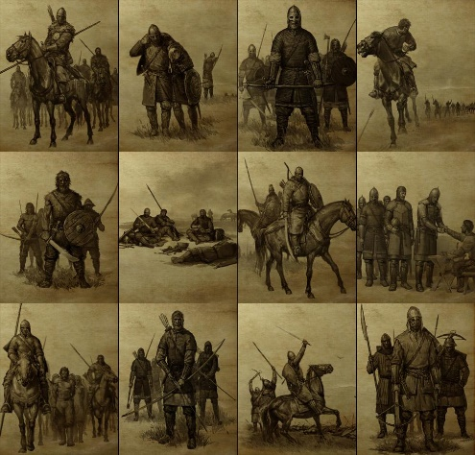 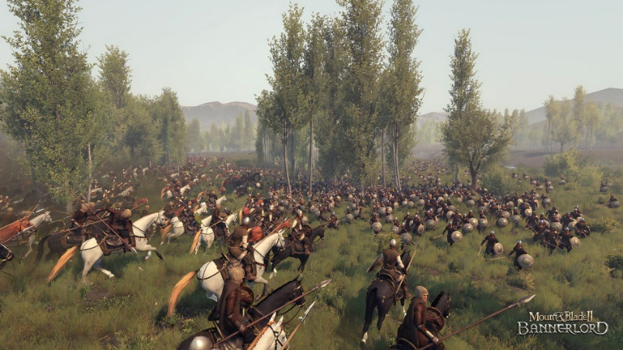

**Kingdom Rush**

* Primary Mood: Playful, energetic, adventurous
* Secondary Mood: Challenging, rewarding

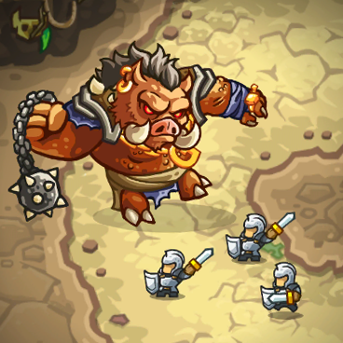 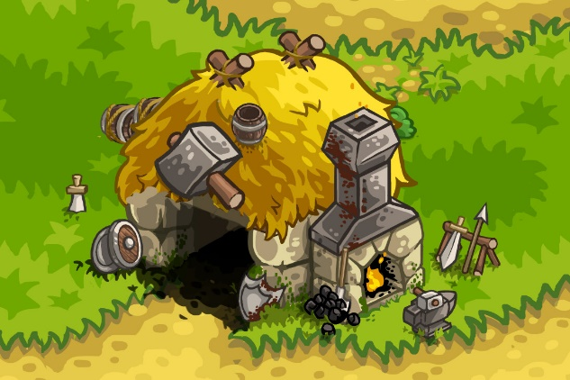

**Dungeon Hunter 4**

* Primary Mood: Dark, intense, action-oriented
* Secondary Mood: Mysterious, dangerous

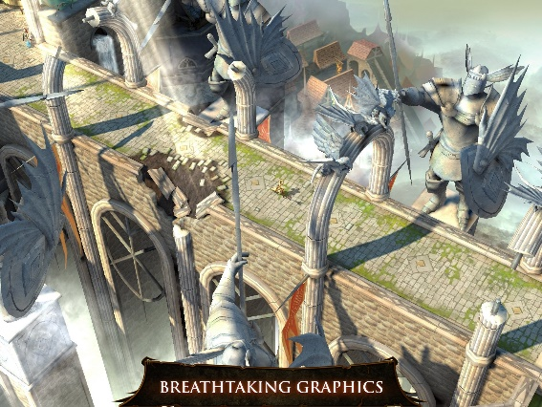 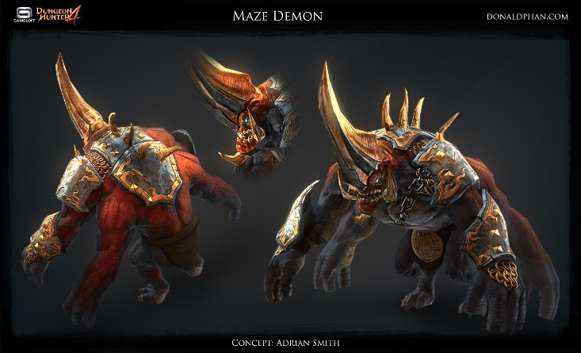

**Clash of Clans**

* Primary Mood: Competitive, strategic
* Secondary Mood: Social, progressive

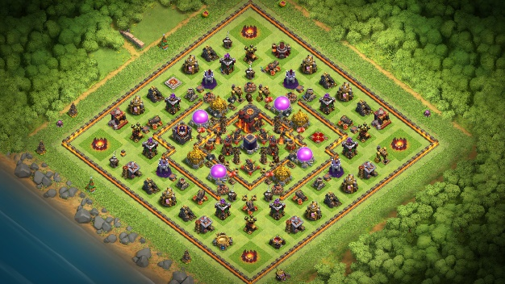 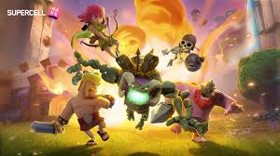

**Dungeon Hunter 5**

* Primary Mood: Dynamic, action-packed, social
* Secondary Mood: Cooperative, competitive

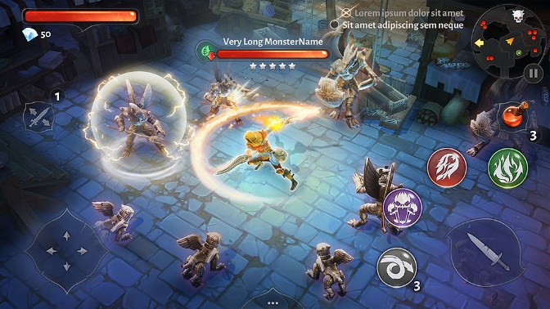 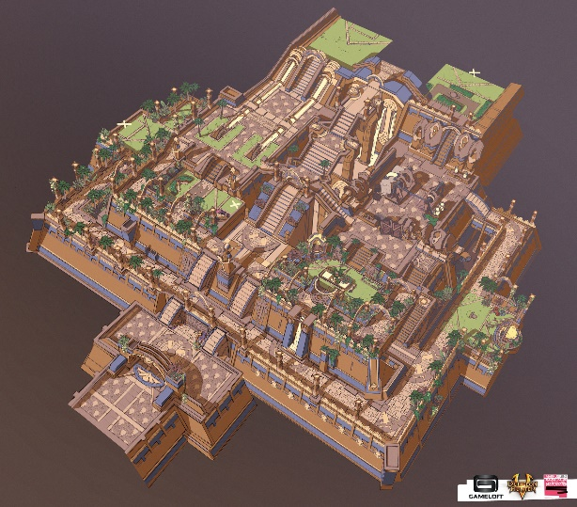

## Influence on Player Experience

**Mount & Blade: Warband:** Serious, immersive medieval warfare experience that grips players with authenticity.

**Kingdom Rush:** Light-hearted yet engaging tower defence experience that grips players with bright colours and simple designs.

**Dungeon Hunter 4:** Gothic fantasy with emphasis on combat intensity [1] that grips players with cool monster/enemy designs.

**Clash of Clans:** Engaging, mildly aggressive base-building experience that grips players with competition and progression.

**Dungeon Hunter 5:** Enhanced social interaction with maintained action intensity [2] that grips players with new designs.

# Audiovisual elements

## Visuals

### Colour schemes

**Mount & Blade: Warband:** Muted earth tones, metallic greys, emphasizing historical authenticity.

**Kingdom Rush:** Vibrant, cartoon-style colours with fantasy elements.

**Dungeon Hunter 4:** Dark fantasy palette with emphasis on blood effects and dramatic lighting [1].

**Clash of Clans:** Bright, cartoon-inspired colours with strategic clarity.

**Dungeon Hunter 5:** Enhanced lighting effects, detailed environments with vertical depth [2].

### Lighting

**Mount & Blade: Warband:** Natural lighting emphasizing time of day and weather.

**Kingdom Rush:** Consistent, clear lighting for gameplay visibility.

**Dungeon Hunter 4:** Dramatic lighting with emphasis on combat effects.

**Clash of Clans:** Clear, consistent lighting for strategic visibility.

**Dungeon Hunter 5:** Enhanced environmental lighting with vertical depth [2].

### Character designs

**Mount & Blade: Warband:** Realistic character design grounded in history.

**Kingdom Rush:** Cartoony character design.

**Dungeon Hunter 4:** Realistic character design with fantasy elements.

**Clash of Clans:** Cartoony character design.

**Dungeon Hunter 5:** Realistic character design with fantasy elements.

### Environments

**Mount & Blade: Warband:** Realistic environment design grounded in history.

**Kingdom Rush:** Cartoony/Stylised environment design.

**Dungeon Hunter 4:** Realistic environment design with fantasy elements.

**Clash of Clans:** Cartoony/Stylised environment design.

**Dungeon Hunter 5:** Realistic environment design with fantasy elements.

### UI Aesthetics

**Mount & Blade: Warband:** Menus have a parchment/scroll appearance and during gameplay there is minimal UI elements, helping with the emersion of the player.

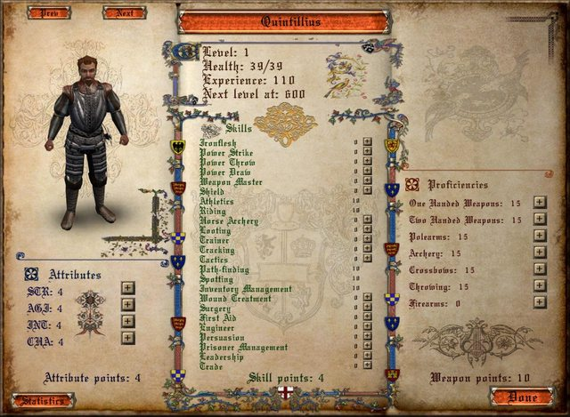 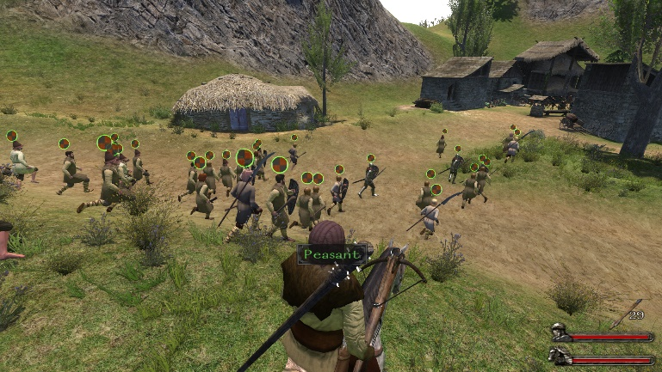

**Kingdom Rush:** Very stylised UI, while having medieval era materials (like parchment, wood and stone), giving a cartoon quality to them that fits with the “energetic” mood of the game.

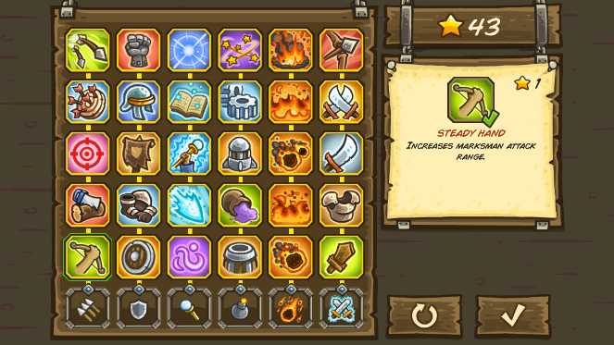 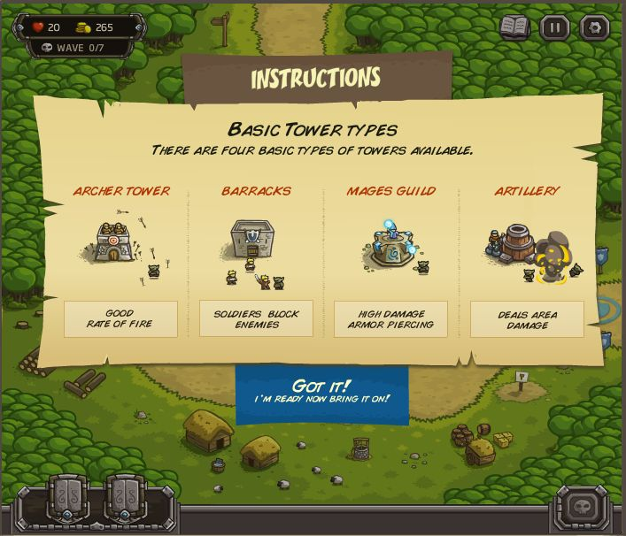

**Dungeon Hunter 4:** More stylised than “**Mount & Blade: Warband**”, but less cartoony than “**Kingdom Rush**”, while also making use of the same “materials” for button borders and menu backgrounds.

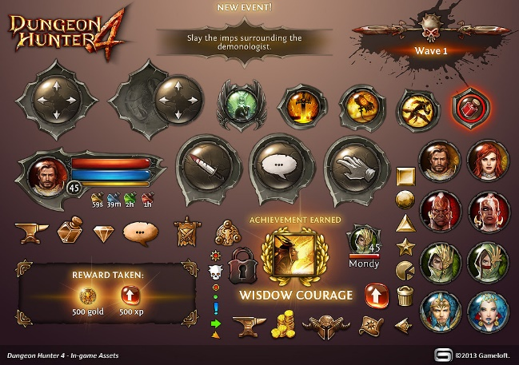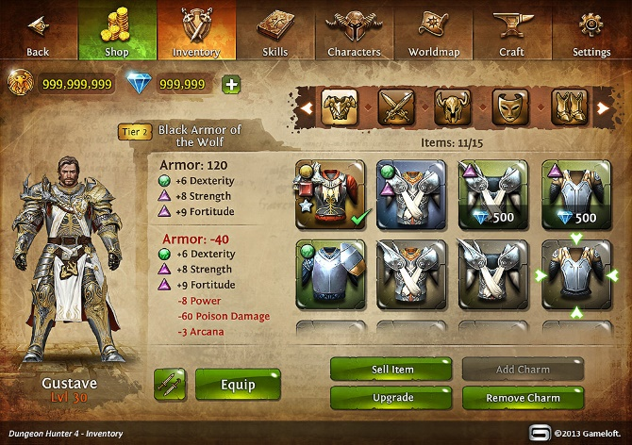

**Clash of Clans:** Clear menu’s and simplified UI, which helps create “visibility” in the game. This is the only “medieval” game that doesn’t make use of the same “materials” as the others. This can also be attributed to the fact that “medieval” isn’t the primary theme.

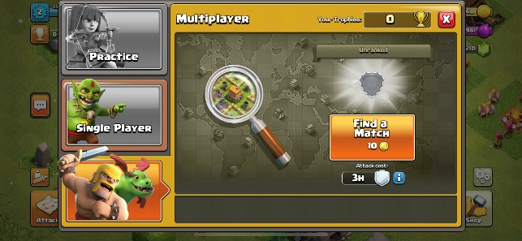 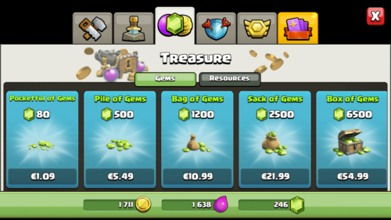

**Dungeon Hunter 5:** More clean and simplified than the UI of “**Dungeon Hunter 4**”. Can also be, because this game feels less “dark” than its predecessor.

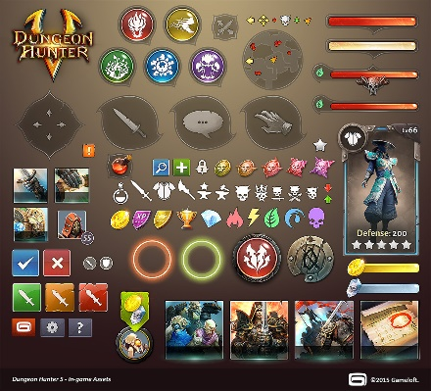 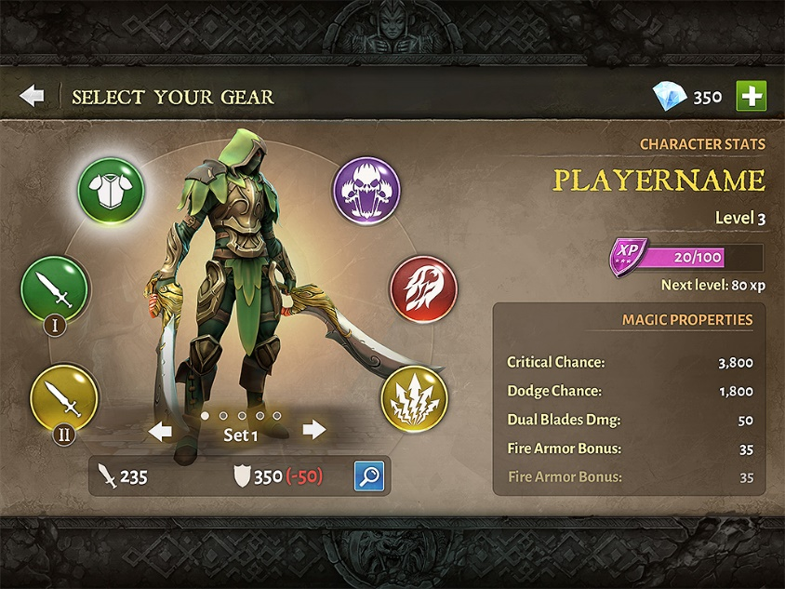

### Shapes

While the shapes used are different in each game, the more stylised games (mainly “**Kingdom Rush**” and “**Clash of Clans**”) use more rounded shapes/corners.

The use of materials is common among all games (parchment, wood and stone) with some exceptions, like: ability buttons, general UI (like health/mana bars) and most of the UI in “**Clash of Clans**”.

## Music and sound effects

**Mount & Blade: Warband:** Period-appropriate medieval music, realistic combat sounds.

**Kingdom Rush:** Upbeat, adventurous soundtrack with cartoon-style sound effects.

**Dungeon Hunter 4:** Dark fantasy soundtrack with emphasis on combat impact [1].

**Clash of Clans:** Strategic sound design with clear action feedback.

**Dungeon Hunter 5:** Dynamic soundtrack adapting to gameplay situations [2].

### Music

**Mount & Blade: Warband:** Period-appropriate medieval music created with flutes, lutes and trumpets (or similar instrument). With the upbeat tempo creating tension and excitement for the player.

<https://www.google.com/url?sa=t&rct=j&q=&esrc=s&source=web&cd=&cad=rja&uact=8&ved=2ahUKEwi9yYSHk-KNAxVinf0HHXFuLl8QwqsBegQIExAF&url=https%3A%2F%2Fwww.youtube.com%2Fwatch%3Fv%3DTgYSIIWYAV8&usg=AOvVaw3TUuNK3NTCnVkQWUP3Z6sG&opi=89978449>

**Kingdom Rush:** Upbeat, adventurous soundtrack created with trumpets and drums. Upbeat tempo creating a “ready for battle” feeling for the player.

<https://www.google.com/url?sa=t&rct=j&q=&esrc=s&source=web&cd=&ved=2ahUKEwiu2qK8k-KNAxU7_7sIHdIsC9EQ78AJegQIGhAB&url=https%3A%2F%2Fwww.youtube.com%2Fwatch%3Fv%3DMuYGWQ4Xg3M&usg=AOvVaw2iy8XLYQcyU4BWNV-2Ii_7&opi=89978449>

**Dungeon Hunter 4:** Dark fantasy soundtrack created with drums, violins and a choir. Emphasis is placed upon certain beats to create a feeling of embarking on a epic (but dangerous) quest.

<https://www.google.com/url?sa=t&rct=j&q=&esrc=s&source=web&cd=&cad=rja&uact=8&ved=2ahUKEwjTqrT7k-KNAxX_qf0HHcNYEHQQtwJ6BAgOEAI&url=https%3A%2F%2Fwww.youtube.com%2Fwatch%3Fv%3D4K5kTx9MJFs&usg=AOvVaw3CxRWSM8mBMWDr829TSyrg&opi=89978449>

**Clash of Clans:** Strategic sound design with clear action feedback created with various instruments (I couldn’t quite pick out which ones). More ambient than the other games, giving room for the clear action feedback that’s essential for this strategy game.

<https://www.google.com/url?sa=t&rct=j&q=&esrc=s&source=web&cd=&cad=rja&uact=8&ved=2ahUKEwiO9622lOKNAxVO1wIHHcZMPHcQwqsBegQIDRAF&url=https%3A%2F%2Fm.youtube.com%2Fwatch%3Fv%3Dwq16HDRoidA%26t%3D1m49s&usg=AOvVaw0RpvT8Wb4ayCNaRN4YnF9v&opi=89978449>

**Dungeon Hunter 5:** Dynamic soundtrack adapting to gameplay situations [2] created with various instruments (because this game has a lot of different tracks, a lot of instruments are used, like: trumpets, tuba’s drums, etc.). The different tracks fit the mood and environment well, making for a immersive experience for the player.

<https://www.google.com/url?sa=t&rct=j&q=&esrc=s&source=web&cd=&cad=rja&uact=8&ved=2ahUKEwir69r3lOKNAxVkxQIHHaxYF5oQwqsBegQIDRAF&url=https%3A%2F%2Fwww.youtube.com%2Fwatch%3Fv%3D4aIlXCwY-3w&usg=AOvVaw3Pw4m-DUyCm9MNwtHwyTRh&opi=89978449>

### Sound effects

**Mount & Blade: Warband:** Realistic combat sounds (swords clashing, battle cries, horse sounds, etc.).

**Kingdom Rush:** Cartoon-style sound effects.

**Dungeon Hunter 4:** Emphasis on combat impact [1] making the player feel powerful (or powerless, depending on if the player is the one getting hit).

**Clash of Clans:** Strategic sound design with clear action feedback.

**Dungeon Hunter 5:** Emphasis on combat impact, just like its predecessor.

# Narrative and theme

## Storytelling

**Mount & Blade: Warband:** Player-driven narrative through choices and actions.

**Kingdom Rush:** Simple, light-hearted narrative framing.

**Dungeon Hunter 4:** Dark fantasy narrative with emphasis on combat progression [1].

**Clash of Clans:** Minimal narrative, focus on strategic progression.

**Dungeon Hunter 5:** Enhanced narrative with social elements [2].

Most of the narration is done through text and not spoken dialogue. The games focus more on the combat than the narrative aspect.

## Themes and motifs

The one they all have in common is the medieval theme. For the more stylised games, the medieval theme is more because of the use of weapons or the appearance of assets. For the other games, the medieval theme is more widely used for environmental design and for “**Mount & Blade: Warband**” the theme is evident in all aspects of the game (including story).

# Gameplay mechanics

## Gameplay contribution

**Mount & Blade: Warband:** Tactical combat and strategic decision-making helping to create an intense, tactical and historically grounded mood.

**Kingdom Rush:** Tower placement and timing-based defence helping to create a playful, energetic and adventurous mood.

**Dungeon Hunter 4:** Action-RPG combat with emphasis on character progression [1] helping to create a dark, intense and action-oriented mood.

**Clash of Clans:** Base-building and strategic resource management helping to create a competitive and strategic mood.

**Dungeon Hunter 5:** Enhanced combat with social features [2] helping to create a dynamic, action-packed and social mood.

## Pacing and challenge

**Mount & Blade: Warband:** Variable pacing based on player actions.

**Kingdom Rush:** Structured waves with increasing difficulty.

**Dungeon Hunter 4:** Progressive difficulty with combat intensity [1].

**Clash of Clans:** Strategic timing and resource management.

**Dungeon Hunter 5:** Dynamic pacing with social interaction elements [2].

# Interaction of elements

## Cohesiveness

**Mount & Blade: Warband:** Unified historical atmosphere through visuals, sound, and mechanics helping to create an intense, tactical and historically grounded mood.

**Kingdom Rush:** Consistent cartoon style across all elements helping to create a playful, energetic and adventurous mood.

**Dungeon Hunter 4:** Dark fantasy atmosphere maintained through combat and visuals [1] helping to create a dark, intense and action-oriented mood.

**Clash of Clans:** Strategic clarity through consistent design elements helping to create a competitive and strategic mood.

**Dungeon Hunter 5:** Enhanced social features integrated with core gameplay [2] helping to create a dynamic, action-packed and social mood.

# Comparative analysis

The games demonstrate distinct approaches to mood creation:

* **Mount & Blade: Warband** and **Dungeon Hunter 4** focus on intense, serious atmospheres.
* **Kingdom Rush** and **Clash of Clans** maintain lighter, more accessible moods.
* **Dungeon Hunter 5** bridges the gap between intensity and accessibility through social features.

# Conclusion

## Summary of key findings

This analysis reveals that successful mood creation in games requires careful coordination of multiple design elements. The most effective games maintain consistency between their visual, audio, narrative, and mechanical elements to create a unified emotional experience. The evolution from **Dungeon Hunter 4** to **5** particularly demonstrates how mood can be enhanced through social features while maintaining core emotional elements [2].

## Implications for game design

1. Consistency across all design elements is crucial for maintaining mood.
2. Social features can enhance mood without compromising core emotional elements.
3. Visual and audio elements should reinforce each other.
4. Gameplay mechanics must support and enhance the intended mood.
5. Platform considerations significantly impact mood creation approaches.

# References

The analysis draws from multiple sources, including detailed reviews of **Dungeon Hunter 4**

[1] [**DUNGEON HUNTER 4 GAME REVIEW — Steemit**](https://steemit.com/gaming/@valency1/dungeon-hunter-4-game-review)

and **Dungeon Hunter 5**

[2] [DUNGEON HUNTER 5(DH5). – kristenjr](https://kristenjr.wordpress.com/2016/10/08/dungeon-hunter-5dh5/)

as well as general game design principles and genre conventions.

[3] [5 Best Medieval Games on Android as of 2025 - Slant](https://www.slant.co/topics/11117/~medieval-games-on-android)